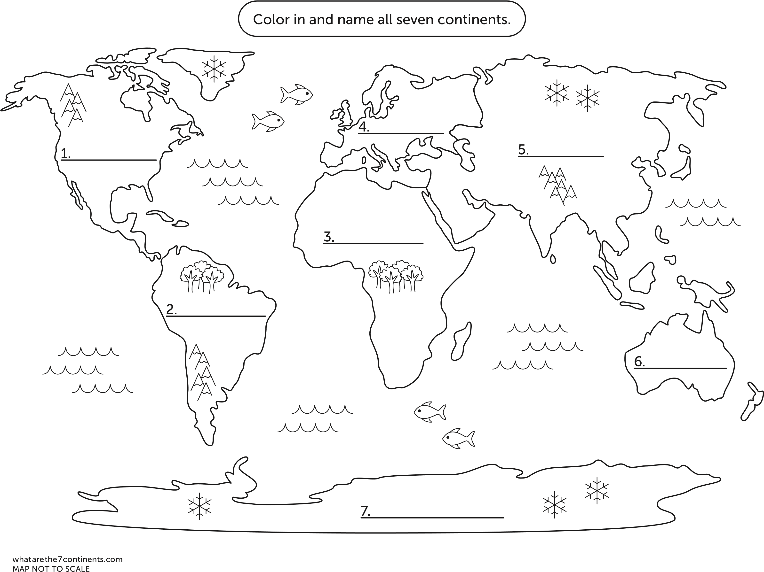

Label the 5 major oceans and colour in. Label the Rainforest areas shade green

Label the mountain ranges – Shade brown Draw and label: Nile, Amazon, Mississippi, Euprates and Ganges Rivers