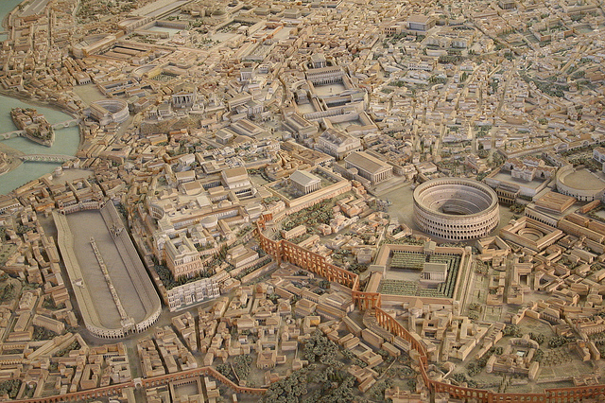
Ancient Civilizations Coding
You will code your way to a presentation about the key elements of an ancient civilization.
You will:
- Research the tasks below. Keep it short, very concise.
- Use a base template of an illustrated map as seen here, 45 degree angle.
- Using Scratch and block coding language, work in pairs to code a tour of the ancient city/village.
Ancient Rome
- Move your character from place to place and change backgrounds at each stop to display your pictures. Have your character speak the tour.
- Choose different civilizations than others in the class. The list is here (do not deviate):
a. Mesopotamia
b. Ancient Greece (pick a specific City State to explore, they varied widely)
c. Ancient Rome
d. Ancient Egypt
e. Ancient India
f. Ancient China
g. Ancient Mayan
h. Indigenous Canadian Villages (Huron or Iroquois suggested but can look into others, but must be sure information is extensive enough)
i. Ancient Isreal
j. Ancient Japanese
k. Medival Europe

Driving Question – How did each element shape the lives of those in your civlization?

4 BROAD TOPICS YOU WILL NEED TO COVER.

- DAILY LIVES
- Social Hierarchy - What was the class system? Could you move from one class to another?
- Jobs – What kinds of interesting jobs did people do? Key specializations?
- Women – What was it like? What were their responsibilities? Did they have a say at all?
- Customs and Dress – What did they wear? Were their special costumes for certain events?
- Entertainment – What were the key sources of entertainment?

- RELIGION AND GOVERNMENT
- Belief System - What were the religious beliefs and practices, rituals, values?
  - The Gods – Part of the religion centered around a number of Gods (Polytheistic). Or centered around a single God (mono-theistic)
- Justice – what were the rules of the land (generally) and how/who enforced? (see Hammarabi's Code for Mesopotamia as an example)
- Politics – Who was in charge? How were they elected, chosen (Divine Right, democracy, ascension)? What kind of country, city structure, did they have and what was the power structure?
- War – Who were the enemies and what key weapons did they use?

- AGRICULTURE
- Water Systems– Control of water was crucial for agriculture and life. How did they prevent flooding, keep a long term water supply over dry periods, survive droughts?
- Food Supply – What did they grow and eat?

- INNOVATION
- Buildings – What architecture did they have, both civic and personal housing?
- Inventions – Give 3 important innovations that occurred to keep track of or improve daily life? It could be scientific, mathematical, tool-based, ideas/warfare techniques, etc.
Work together, be creative, and present a clear and concise presentation. We will work ‘til we are all mostly done. Work hard, do some homework, divide your tasks.
