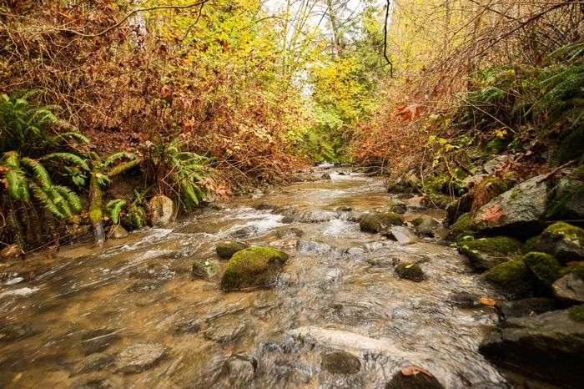

**Fascieux Creek Restoration Project – Phase 2 – Active Management, Education, and Continued Development**

**INSTRUCTIONS: Visit FASCIEUX CREEK NATURE PRESERVE and Observe DIFFERENCES, COOL IDEAS FOR US, THINGS YOU DIDN'T LIKE, WHAT YOU CONNECT WITH. Submit for completion mark.**

**Differences… I connect with…**

**Cool Ideas…**

**What I didn't like…**

**Name:_________________________**

**NAME:**

**asdfasdf**