Write the important information about each of the Empires.
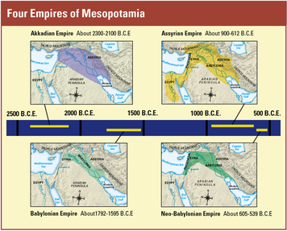
_____________________________________________________________________________________________________________________________________________________________________________________________________________________________________________________
_____________________________________________________________________________________________________________________________________________________________________________________________________________________________________________________
_____________________________________________________________________________________________________________________________________________________________________________________________________________________________________________________
_____________________________________________________________________________________________________________________________________________________________________________________________________________________________________________________
Which Empire would have you have most liked to have been a part of and why?__________________________
____________________________________________________________________________________________
____________________________________________________________________________________________
____________________________________________________________________________________________

Legend of Gilgamesh
- What is Gilgamesh seeking and why? ________________________________________________________
____________________________________________________________________________________________

- What are 5 plot events from the point where we pick up the show (be sure to finish the story). Discuss then write.
  - ________________________________________________________________________
  - ________________________________________________________________________
  - ________________________________________________________________________
  - ________________________________________________________________________
  - ________________________________________________________________________

Fertile Crescent and Agriculture Video
- What 2 rivers make up the "Fertile Crescent"? ___________________ and ______________________.
- List 5 crops grown. ______________, __________________, ________________, ________________, __________________
- Name for a walled independent city in Mesopotamia - ______________________________________
- Inventions: ________________, __________________, ____________________, _________________, ______________, _____________________, ___________________.
Levee - __________________________________________________________
ditches - _________________________________________________________
Gates - __________________________________________________________

Things you should also know well by now (and on week end quiz). – Use the Review Crossword to study.
- Most of the inventions of the day
- The general idea of religion
- A few of the crops grown, how agriculture worked.
- Social Structure: Kings and Priests, Nobles, Scribes (and jobs involving writing/numbers), merchants, artisans, commoners and farmers, slaves.

