Discovery - February 25, 2011
Brown-eyed, bearded, furrow faced, and tired: this is how Otzi the Iceman might have looked, according to the latest reconstruction based on 20 years of research and investigations. The model was produced with the latest in forensic mapping technology that uses three-dimensional images of the mummy's skull as well as infrared and tomographic images. The new reconstruction shows a prematurely old man, with deep-set eyes, sunken cheeks, a furrowed face and ungroomed beard and hair. Although he looks tired, Otzi has vivid brown eyes. Indeed, recent research on the 5,300-year-old mummy has shown that the Stone Age man did not have blue eyes as previously thought. Believed to have died around the age of 45, Otzi was about 1.60 meters (5 foot, 3 inches) tall and weighed 50 kilograms (110 pounds).

Health
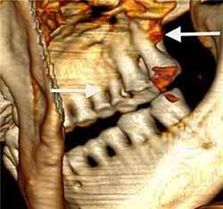
Otzi apparently had whipworm (Trichuris trichiura), an intestinal parasite. During CT scans, it was observed that three or four of his right ribs had been cracked when he had been lying face down after death, or where the ice had crushed his body. One of his fingernails (of the two found) shows three Beau's lines indicating he was sick three times in the six months before he died. The last incident, two months before he died, lasted about two weeks.
Also, it was found that his epidermis, the outer skin layer, was missing, a natural process from his mummification in ice. Otzi's teeth showed considerable internal deterioration from cavities. These oral pathologies may have been brought about by his grain-heavy, high carbohydrate diet. DNA analysis in February 2012 revealed that Otzi was lactose intolerant.

Analysis of Otzi's gut contents showed two meals, one of ibex meat, the second of red deer meat, both consumed with some grain. Pollen in the first meal showed that it had been consumed in a mid-altitude conifer forest.

Analysis of Otzi's intestinal contents showed two meals (the last one consumed about eight hours before his death), one of chamois meat, the other of red deer and herb bread. Both were eaten with grain as well as roots and fruits. The grain from both meals was a highly processed einkorn wheat bran, quite possibly eaten in the form of bread. In the proximity of the body, and thus possibly originating from the Iceman's provisions, chaff and grains of einkorn and barley, and seeds of flax and poppy were discovered, as well as kernels of sloes (small plumlike fruits of the blackthorn tree) and various seeds of berries growing in the wild. Hair analysis was used to examine his diet from several months before.

Pollen in the first meal showed that it had been consumed in a mid-altitude conifer forest, and other pollens indicated the presence of wheat and legumes, which may have been domesticated crops. Pollen grains of hop-hornbeam were also discovered. The pollen was very well preserved, with the cells inside remaining intact, indicating that it had been fresh (a few hours old) at the time of Otzi's death, which places the event in the spring. Einkorn wheat is harvested in the late summer, and sloes in the autumn; these must have been stored from the previous year.

High levels of both copper particles and arsenic were found in Otzi's hair. This, along with Otzi's copper axe which is 99.7% pure copper, has led scientists to speculate that Otzi was involved in copper smelting. By examining the proportions of Otzi's tibia, femur and pelvis, Christopher Ruff has determined that Otzi's lifestyle included long walks over hilly terrain. This degree of mobility is not characteristic of other Copper Age Europeans.

Tattoos

Otzi had 57 tattoos, some of which were located on or near acupuncture points that coincide with the modern points that would be used to treat symptoms of diseases that Otzi seems to have suffered from, such as digestive parasites and osteoarthrosis. Some scientists believe that these tattoos indicate an early type of acupuncture.

Otzi had several carbon tattoos including groups of short, parallel, vertical lines to both sides of the lumbar spine, a cruciform mark behind the right knee, and various marks around both ankles. Radiological examination of his bones showed "age-conditioned or strain-induced degeneration" in these areas, including osteochondrosis and slight spondylosis in the lumbar spine and wear-and-tear degeneration in the knee and especially the ankle joints. It has been speculated that these tattoos may have been related to pain relief treatments similar to acupressure or acupuncture. If so, this is at least 2000 years before their previously known earliest use in China (c. 1000 BCE).

The 57 tattoos were made from fireplace soot that contained glittering, colorful precious stone crystals,

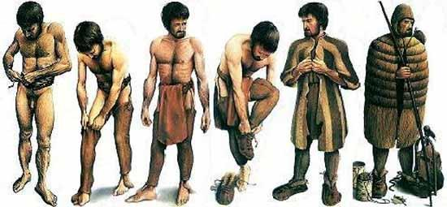

Clothes worn by Otzi the Iceman 5,300 years ago include hay-stuffed shoes, goat- and sheepskin coat, goatskin leggings, bear fur hat, grass matting and sheepskin loincloth.

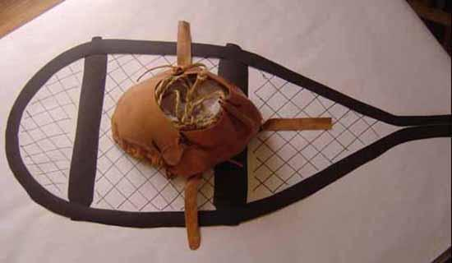
Otzi's shoes were waterproof and wide, seemingly designed for walking across the snow; they were constructed using bearskin for the soles, deer hide for top panels, and a netting made of tree bark. Soft grass went around the foot and in the shoe and functioned like warm socks. The shoes have since been reproduced by experts and found to constitute such excellent footwear that there are plans for commercial production.

One set of items found were a quiver of 14 arrows with viburnum and dogwood shafts. Two of the arrows, which were broken, were tipped with flint and had fletching (stabilizing fins), while the other 12 were unfinished and untipped. The arrows were found in a quiver with what is presumed to be a bow string, an unidentified tool, and an antler tool which might have been used for sharpening arrow points. There was also an unfinished yew longbow that was 1.82 metres (72 in) long

In addition, among Otzi's possessions were berries, two birch bark baskets, and two species of polypore mushrooms with leather strings through them. One of these, the birch fungus, is known to have antibacterial properties, and was probably used for medicinal purposes. The other was a type of tinder fungus, included with part of what appeared to be a complex firestarting kit. The kit featured pieces of over a dozen different plants, in addition to flint and pyrite for creating sparks.

Otzi's copper axe was of particular interest. The axe's haft is 60 centimetres (24 in) long and made from carefully worked yew with a right-angled crook at the shoulder, leading to the blade. The 9.5 centimetres (3.7 in) long axe head is made of almost pure copper, produced by a combination of casting, cold forging, polishing, and sharpening. It was let into the forked end of the crook and fixed there using birch-tar and tight leather lashing. The blade part of the head extends out of the lashing and shows clear signs of having been used to chop and cut. At the time, such an axe would have been a valuable possession, important both as a tool and as a status symbol for the bearer.

Among Otzi's possessions were two species of polypore mushrooms. One of these (the birch fungus) is known to have antibacterial properties, and was likely used for medical purposes. The other was a type of tinder fungus, included with part of what appeared to be a complex firestarting kit. The kit featured pieces of over a dozen different plants, in addition to flint and pyrite for creating sparks.

DNA analysis revealed traces of blood from four other people on his gear: one from his knife, two from the same arrowhead, and a fourth from his coat.

A CAT scan revealed that Otzi had what appeared to be an arrowhead lodged in one shoulder when he died, matching a small tear on his coat. The arrow shaft had been removed, apparently by a companion.

Otzi had bruises and cuts on his hands, wrists, and chest.

Using just a pinhead-sized sample of brain tissue from the world-famous glacier corpse, the team was able to extract and analyze proteins to further support the theory that Otzi suffered some form of brain damage in the final moments of his life 5,300 years ago.

The majority of the pollen came from the hop hornbeam tree, which grows in a warm environment. The hop hornbeam tree blooms between March and June, and because the sperm inside the pollen grain, which normally decays after a short exposure to air or water, was still intact, it had to have been absorbed relatively soon after its release from the tree. The nearest stands of that tree could have grown to the south of the Hauslabjoch, at least five or six hours away by foot. The high valleys to the north are just too cold to sustain it.

