3 PARTS OF A STORY
We are going to write a story in groups of 3. You will write each part of a fairly short story. Think beyond the obvious, maybe try to be metaphorical if you want. Do not rush into action and follow the steps of each part. ALSO, honour what has been said in the past, you cannot change a story just to fit your needs. If you find yourself going too fast, slow down and describe or have people talk.
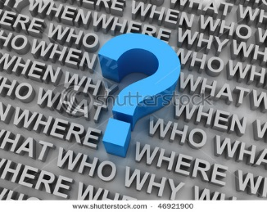
THE INTRODUCTION
The first part of a story is the beginning. This part of the story lets us know a little bit about the characters, setting, and plot . It helps us understand who, what, where, and when. It ends at the "Inciting Incident", the point of no return for our protagonist.

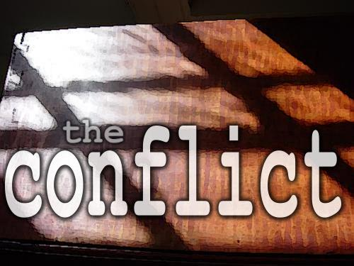
THE MAIN CONFLICT
The second part of any story is the middle. In the middle of the story there is some type of conflict . The conflict begins in the middle and is usually resolved later during the third part of the story. This is where all the main struggle of the story occurs. The longest part.

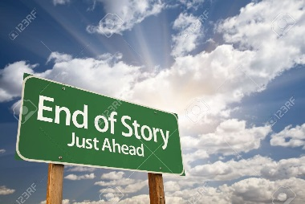
THE RESOLUTION
The last part of the story is the end. The end of the book finds a resolution or resolves the conflict. The end is when the beginning starts becoming a finalized story. Endings help us answer the question of how. How is the story finished and how is the conflict resolved? The ending is fairly short compared to other parts.

