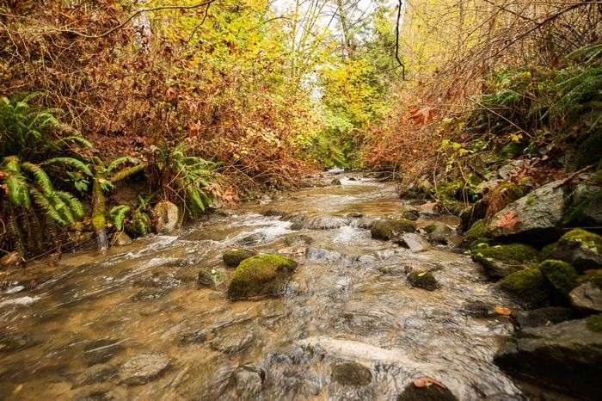

**I NOTICE I WONDER I WISH**

**NAME:**

**asdfasdf**

**Fascieux Creek Restoration Project – Phase 2 – Active Management, Education, and Continued Development**