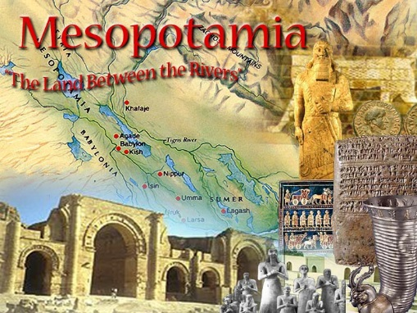
Ancient Mesopotamia
Mini – Presentations
Let's Take a Look at Arguably the world's OLDEST civilization.

You will have 2 classes to create a presentation in groups of 4 (maybe 5) YOUR BATTLE OF THE BOOK GROUPS, about Mesopotamia. The following will help:
- Divide up the tasks as outlined below.
- Sort through the material, do not plagiarize (use summary strategies like that used in OTZI),
- Each person will report on one of the following 4 categories. An extra person needs to be given a specialist task such as a uniting game, video researcher, etc.
- Don't be afraid to go beyond report and include simulations, activities and games which bring out the meanings more.

4 BROAD TOPICS YOU WILL COVER.

Driving Question – How did each element shape the lives of those in Mesopotamia?

- DAILY LIVES
- Social Hierarchy - What was the class system in Mesopotamia? Could you move from one class to another?
- Jobs – What kinds of interesting jobs did people do?
- Women in Mesopotamia – What was it like? What were their responsibilities? Did they have a say at all?
- Customs and Dress – What were some traditional customs? Were they based on religion, the environment, Rites of Passage, etc? What did they wear? Were their special costumes for certain events?

- RELIGION AND GOVERNMENT
- Belief System - What were the religious beliefs and practices, rituals, values?
  - The Gods – Part of the religion centered around a number of Gods. In this one, look only at the mythology side of this – who were the Gods and what were they responsible for?
- Justice – what were the rules of the land (generally) and how/who enforced? (see Hammerabi's Code)
- Politics – Who was in charge? How were they elected, chosen? What kind of country, city structure did they have and what was the power structure?
- War – How was war conducted, who fought and why?

- AGRICULTURE AND TRADE
- Water Systems and food supply– Control of water was crucial for agriculture and thus their entire way of life. How did they prevent flooding, keep a long term water supply over dry periods, survive droughts?
- Specialization – What jobs were considered more important? What items did people make and trade with other citizens and cities? Any areas known for certain types of goods.

- INNOVATION
- Buildings – What architecture did they have, what did form do for function and livability? Discuss both high end and functional housing.
- Inventions – Give 3 important innovations that occurred to keep track of or improve daily life? Think beyond anything that was mentioned yet.
- Celestial Developments and purpose – explore the meaning and importance of the stars.

Work Together, Be Creative, and present a Clear and concise presentation.

