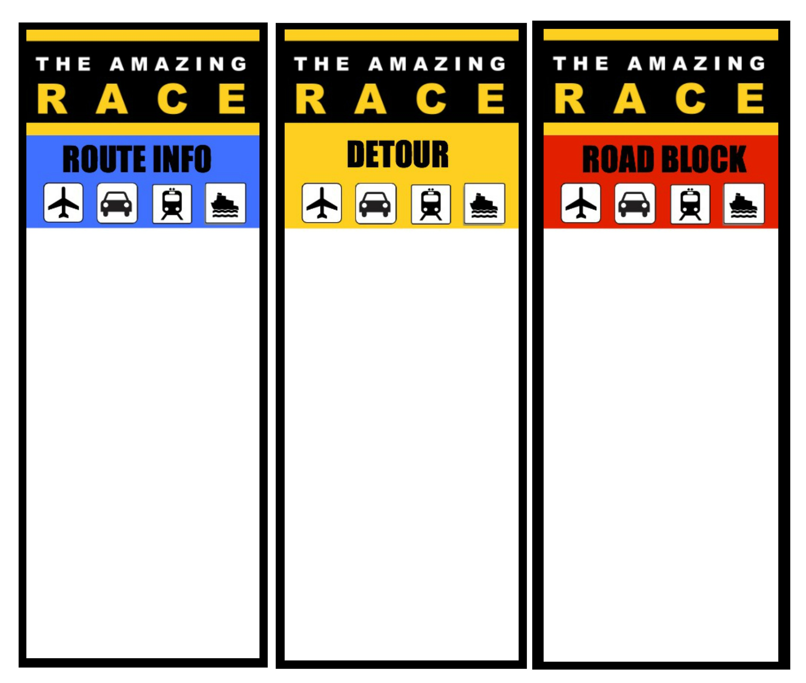

On the computer, piece the puzzle together of the human skeleton. Google – "Anatomy arcade skeletal jigsaw"

Observe well.

Get your next clue.

Completion Time _________

**Station 1** – Welcome to the Amazing Race to Civilization

**Where did it all start?**

**TASK**: Find out using the internet where one of the earliest "people", known as LUCY is located. Get yourself a flight there. You will lose a minute for every hour behind the first team to arrive there so take your time.

**When you are completed submit your landing time here and receive your next clue.**

**Landing time: _____________**

**Landing Date:______________**

**Completion Time: __________**

Keep all slips. Submit at end or receive a penalty of 1 minute per slip missing.

**Station 4** – Fire is very important to life as we know it; however, because it allows humans to safely eat foods that would otherwise be harmful or impossible to eat, reduces calorie requirements, and allowed man to thrive in cold climates. This greatly expanded humankind's options for thriving, and we would have remained primitive without it.

**TASK : Reconstruct the fire scene under the bucket.** Take note of all the details

**Only 1 person can visit the display at a time. Working must stop when someone is looking. No shouting back**, bring answers to the table.

***Proceed to the finish line when your task is complete.  
Completion time: _________***

***Penalties_____ total ________***

**Station 2**– **Reconstructing Lucy**

**Lucy** is the common name of **AL 288-1**, several hundred pieces of bone fossils representing 40 percent of the skeleton of a female of the [hominin](https://en.wikipedia.org/wiki/Hominin) species [*Australopithecus afarensis*](https://en.wikipedia.org/wiki/Australopithecus_afarensis). Lucy was discovered in 1974 near the village [Hadar](https://en.wikipedia.org/wiki/Hadar,_Ethiopia) in the [Awash Valley](https://en.wikipedia.org/wiki/Awash_Valley) in [Ethiopia](https://en.wikipedia.org/wiki/History_of_Ethiopia) by [paleo-anthropologist](https://en.wikipedia.org/wiki/Paleoanthropologist) [D. Johanson](https://en.wikipedia.org/wiki/Donald_Johanson).

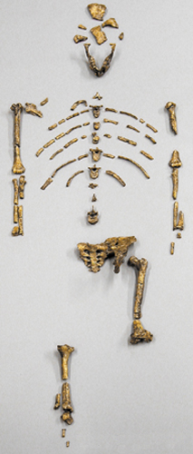

**Station 3** – Tracing the Lineage.

Man has developed through several key stages towards who we are today.

You will receive a series of names and dates, along with a description and picture. Arrange these in the correct order to receive your next clue. You may all work as a team on this.

When you have completed this task, come for your next clue.

Completion time: ___________