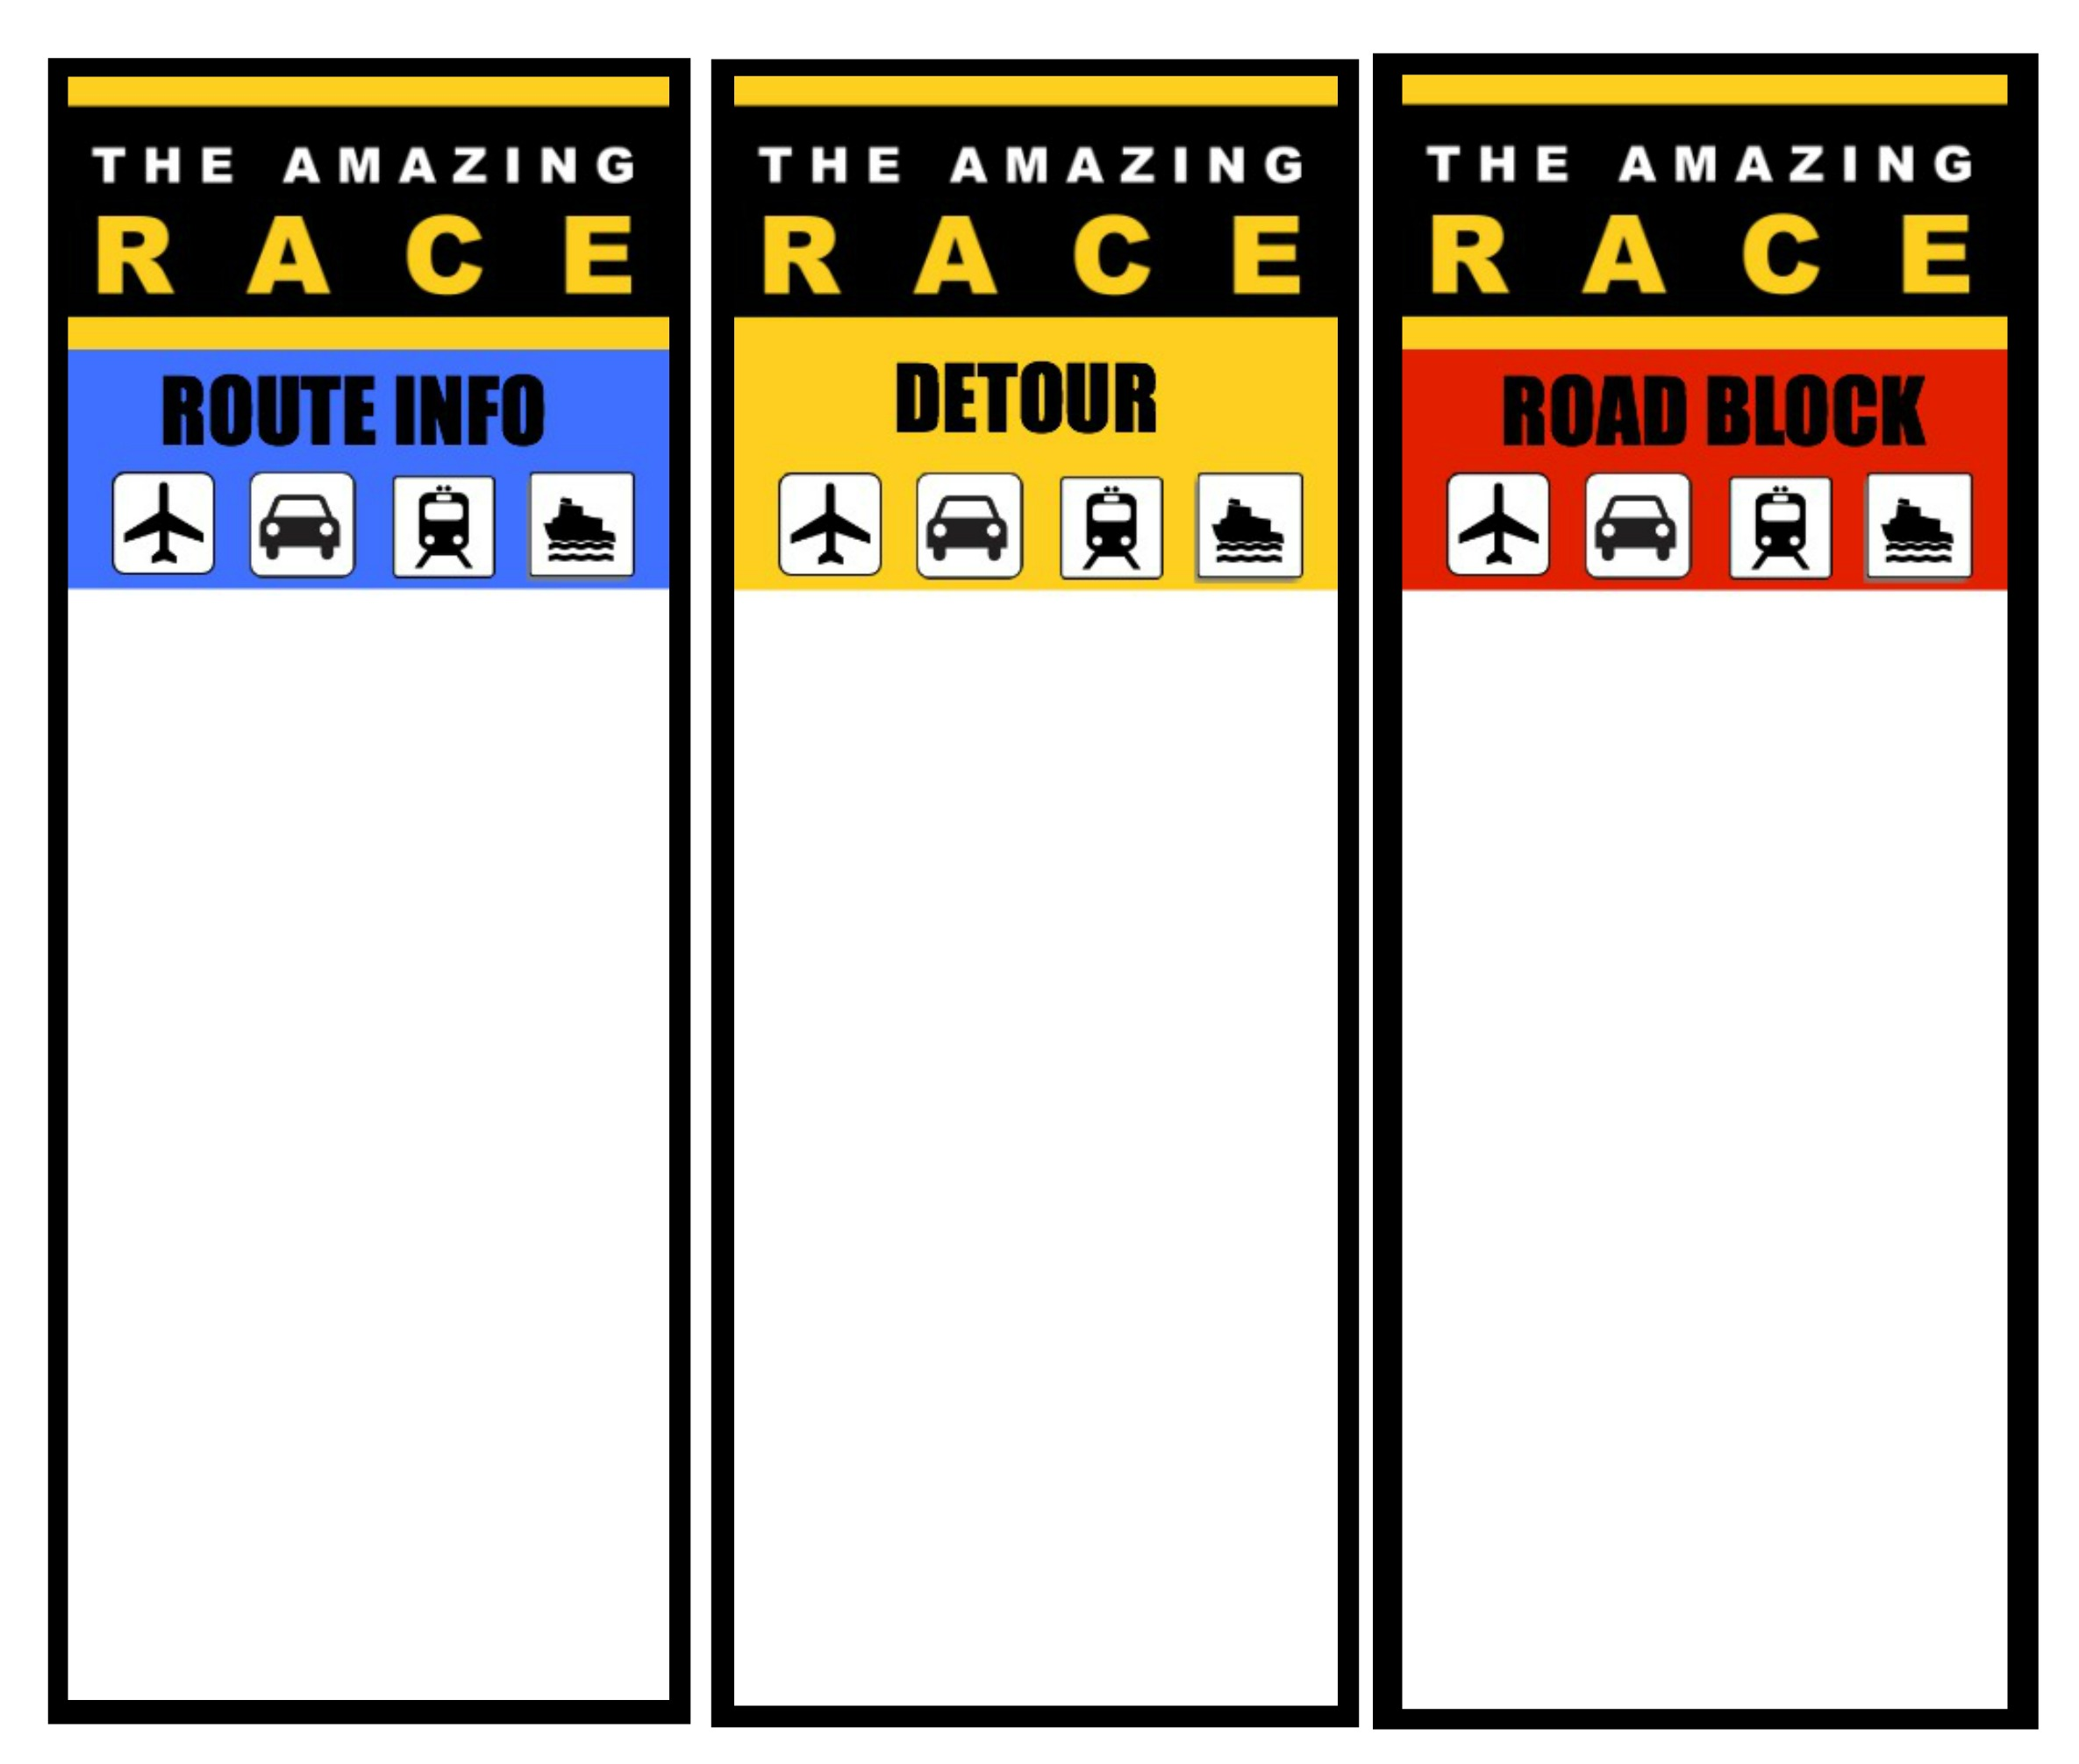

ENTER INSTRUCTIONS HERE – This may take you off the beaten path, an experience to show me something unique about an aspect of the culture. Perhaps an agricultural, artistic, technology, leisure activity? Could there be an on-line element or short game that is based on the culture?

One final task. Could this be looking for something posted around the room to solve a puzzle? Could this involve putting something difficult in order, or matching something up (e.g. laws to punishments, gods to their responsibilities)? Might they have to reconstruct something according to a detailed ceremony, building, artwork?)

After completed, where do they have to go for their checkpoint? Give them a clue to an important landmark they have to know for check-in.

ENTER INSTRUCTIONS HERE – At this point the team must stop and complete a task before carrying on. This could be an experience to show me something unique about an aspect of the culture. Perhaps an agricultural, artistic, technology, leisure activity? Could it involve memorization or sequencing around math, religion, language? Could it be a problem or puzzle to solve using ancient techniques?

ENTER INSTRUCTIONS HERE – Travel marker – Where should I go or what do I have to find? Is there a small task there too?