Fascieux Creek Passion Project
Student Workbook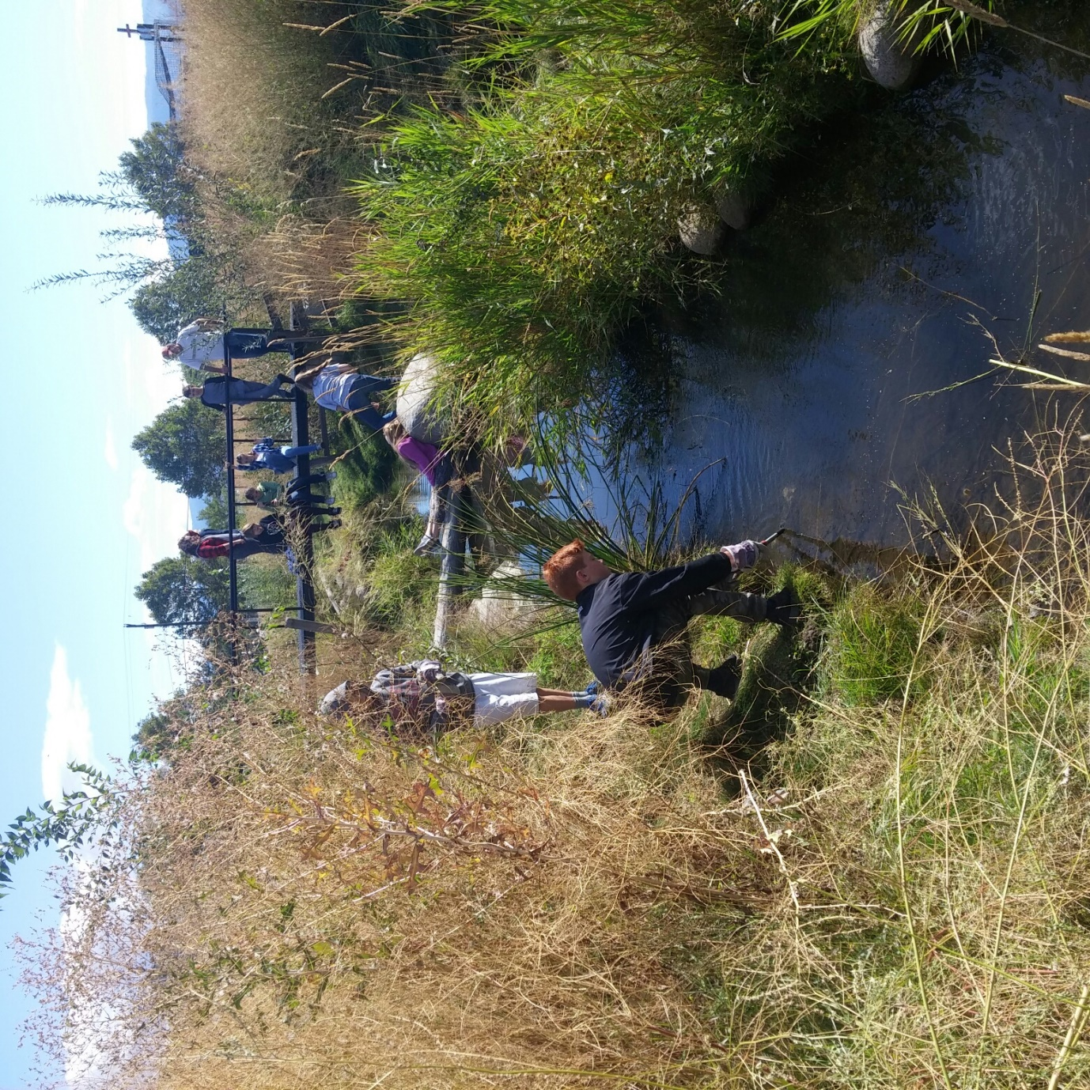
Name ______________________ Period_____
Partners (if applicable) _________________________

This project is a chance to get involved with a very important project for our school and reclaim and enhance the original visions of the creators. This is the original vision and project proposal in 2013.
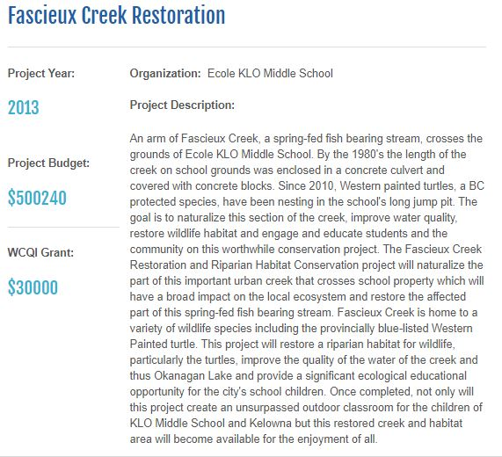

THE REALITY
Though the ecosystem has been meticulously planned and built, for such an ecosystem to thrive, it requires management. Students have noticed garbage, an abundance of invasive weeds, and a slow return of the turtles to date. This inquiry study will help to answer some of the management questions and chart a course for the future of this invaluable educational and ecologically important environment. And you will get to be a part of that.

Exercise 1 – Understanding the Vision
Name - _________________________
Look at the Restoration Proposal on page 2 and determine the key information, and find what you best connect with.

- How much was the whole project cost? ________________________

- What 2 important animal species are listed here?
  - ___________________
  - ___________________

- What were the 3 primary objectives of the project?
  - _____________________________________________________
  - _____________________________________________________
  - ______________________________________________________

- Look at the last sentence. Find one short phrase that "resonates" with you and explain why.
Phrase: _____________________________________________
Meaning to you:

- Planning and building such a big project is awesome, but what did the budget forget to do, and how can this be fixed now?

- What about this newly revitalized ecosystem and your interaction within it has grabbed your attention the most?

FASCIEUX CREEK PASSION PROJECTS
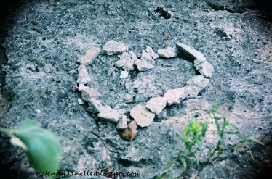
Because we learn best when we are doing something we love, you get to choose a project associated with the creek that you are passionate about. Outlined below are the types of projects that can be done. If you have another idea, feel free to suggest it.

DRIVING QUESTION: How can an ecosystem within an educational environment be properly managed to create and foster ecological awareness, creativity, stewardship, and belonging?

Types of Projects

- Ecosystem Cataloguing or mapping – In this type of project you catalogue species numbers, heights, health, etc. in order to provide a benchmark for the stream habitat, and determine future success. This can be done for both animals and plants. Mapping of the areas and species present would also be an excellent project.
Driving questions: What species exist in the ecosystem and in what abundance and where?
What is the spatial layout of the ecosystem?
How would different cultures view and map this habitat?
(indigenous, engineer, ecosystem manager, educational director, etc).

- Education, enjoyment and awareness – This is a broad category that houses many facets. Taking on a project in this area could include building signposts for plants or creating ecosystem models, submitting articles to newspapers or school newsletters, educating the student body about stewardship, running contests that promote the streams value, and building ideas for innovative ways for others to interact with stream in meaningful ways.
Driving questions: How can the stream become learning for all?
Can we get funding and support for more development?
How can we educate the community and school body on careful use of the stream?
How can we develop activities that stimulate creativity and connection to the creek?
How can this habitat be used for mindfulness activities, to create sustained awareness, and bring a true joy of nature to the school community?
How can the habitat serve as an exemplar for other schools and locations and how do we educate others in the community and abroad about what we have done?
What strategies can we implement to show progress, development, learning and enjoyment that all can have access to (e.g. Website, book, etc.)

- Innovation and Design - In this type of project, you develop and create, using engineering and landscape design to "fashion" the riparian zone into a vibrant, safe and somewhat accessible and thriving habitat and learning center. In this type of project, you ask a question, and provide a real, on the ground, solution that fits well with the desired use and initial intent of the Fascieux Creek project. This is related to new design features such as ways to move water quicker, improve water quality, add features such as waterfalls to stimulate water movement, provide strategic access points while still protecting key habitat areas, designing better habitat protection barriers, adapting existing areas for better use, or any other "I wish" you could propose.

Driving questions: Is it possible to add path networks to provide access while still protecting the integrity of the riparian zone and protected areas?
What features could be added to provide water flow?
Would irrigation help suppress invasive weeds, and how can that be achieved?
How can water quality be improved?
How can erosion be prevented?
What structural modifications need to be made to manage foot traffic effectively?

- On-going Ecosystem Management – This area focusses on the maintenance and development of the existing habitat, and improving what already exists. Weed control is a real problem, strategies to deal with this is crucial. Looking at and cataloguing of invasive species and possible suppression techniques would be invaluable. Also, protecting and improving turtle nesting areas and any other habitat zones is very important.

Driving questions: Is the introduction of species viable, or even desirable. Which ones?
What concerns exist around erosion, animal stress, misuse, and how does one manage this?
Can we get funding and support for more development?
What programs need to be in place to monitor and protect the habitat from litter, abuse, etc.?
Can trees be planted, and how would they be protected from drought conditions?
Could ancient or current watering techniques be used as inspiration for provide necessary water to certain locations during certain times of the year?
What invasive species exist and how can natural techniques manage their damage?

- Study - In this type of project you do extensive research on a topic, write a research paper and perhaps produce charts and graphs about what you found in your research. If you choose data collection, the analysis data should be extensive, and will include many graphs and charts. The studies might involve animal (including humans) subjects and behaviours, water quality variations over the year, observation and pattern, and changes in human behavior over time with differing variables applied (e.g. pre and post education sessions).

Driving questions: How do the bird populations change based on different vegetation or housing treatments?
How does opening an area by weeding increase erosion vs. non weeding?
What is the pH and/or sedimentation affected by different climate events?
What is the flow rates and depths over the course of a season?
How does connectivity education impact positive and negative uses of the creek?
How effective are structural changes on usage/misuse?

YOUR PROJECT IDEA:
DRIVNG QUESTION:
TEACHER SIGNOFF______
TIMELINE AND PROJECT ELEMENTS

THERE ARE THREE MAIN PARTS TO YOUR INQUIRY PROJECT:
  - Project Planning (#1-4)
  - Project Execution (#5)
  - Project Reporting (#6-9)

The General Project Progression
  - Question - What is the DRVING QUESTION for your project?
  - Background information - In short essay format, describe the importance of your topic, any pertinent information to its successful resolution, and perhaps even outline other projects on this topic that have been done in the past, or has an impact on your ideas
  - Hypothesis - What do you think you will find out? OR What do you think your intervention/ideas will ultimately achieve? What are other possible outcomes?
  - Materials – Write a list of materials/tools/resources you will need to achieve your project outcome.
  - Procedures and PROJECT WORK! – Step by step process of how you will/did achieve your outcome. This is the core of the project. I like to think critically about all projects with a lens of "INTENT, PROCESS, OUTCOME". The intent may be sincere, but if the process is flawed, then the outcome can be disastrous. Revisit often to be sure you don't fall prey to misguided good intentions.
- Results and Discussion – You need to summarize your results from an ecological, educational, engineering or other perspective. Photos, charts, reports, survey results, newspaper articles, contest results, etc. can all demonstrate the outcome. What problems did you encounter and overcome along the way? Outline what you have achieved or learned? Was your hypothesis correct? How would you change it, in retrospect?
- Conclusions and Acknowledgements – You have been a part of Year 1 of the Stream Management Project, what will it take in future years to continue along the trajectory you have set out. Any ideas around how this can be achieved? Give thank-you's to any parent, teacher, community member, organization who helped you.
- Bibliography – List any book/web sources you used. Be sure to be thorough in your research and use quality, respected sources.
- Reflections – Character Strong elements, personal growth, collaboration and goal setting will be a part of the project. Be sure to thoughtfully complete.

TASK LIST
The table below is a task list and suggested timeline to help organize you for the Science Inquiry Project. If you follow this timeline you'll be calm and cool on Presentation day! You will develop some of your own dates, based on factors that will be unique to your project, others will be given to you.

You will have time in class to work on your project, so it is a good idea to have your work with you (on OneDrive, Google Drive, a USB drive, or email) at all times, so you can access it. We will set some time aside, but you may also need to do homework on other topics assigned in class to free up time to work on your Ecosystem Passion Projects. Also, CHOOSE PARTNERS WISELY. Remember you always have the choice to do this project by yourself. You may also work with people in other classes! We will be highly interactive in GOOGLE DOCS, so it won't be hard to coordinate.

The classroom, and resources in it, will also be available most at lunch if you need work space, help, and or use of the laptops or tools for the Ecosystem.

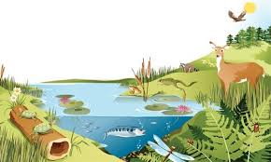
Project Proposal - Ecosystem Inquiry
****DETACH AND HAND IN WHEN COMPLETED****
Name(s): ______________________________
______________________________

- What driving question are you going to investigate?
______________________________________________________________________________
__________________________________________________________________________________________________________________________________________________________________________________________________________________________________________

- Why do you think this is an appropriate, important and/or interesting topic?
__________________________________________________________________________________________________________________________________________________________________________________________________________________________________________

- Does your project follow the original intent of the Project on page #2? Yes / No. If “Yes”, move on. If “No”, reconsider your project.

- Is your project specific and clear enough to be completed in 1 year with the manpower of your group? Yes / No. If “YES”, move on. If “NO”, reconsider your project. Will you be able to get help? Can you be more specific? Can you start it and create a feasible multi-year plan for others to follow?

- What is your hypothesis? (What do you PREDICT will happen)? Answer in the form of an "If… then…" statement.
_________________________________________________________________________________
__________________________________________________________________________________________________________________________________________________________________

- What MATERIALS do you need for your study or experiment? Be specific.
_________________________________________________________________________________
__________________________________________________________________________________________________________________________________________________________________ _________________________________________________________________________________
_________________________________________________________________________________
_________________________________________________________________________________
_________________________________________________________________________________

- In six points, outline how you are planning on doing your experiment, study, project. Be specific and clear in each step.
_________________________________________________________________________________
_________________________________________________________________________________
_________________________________________________________________________________
_________________________________________________________________________________
_________________________________________________________________________________
_________________________________________________________________________________
_________________________________________________________________________________
_________________________________________________________________________________
_________________________________________________________________________________
__________________________________________________________________________________________________________________________________________________________________
_________________________________________________________________________________
9. What safety precautions are necessary for your project (social or physical)?_________________________________________________________________________
_________________________________________________________________________________
_________________________________________________________________________________ _________________________________________________________________________________
10. What can your parents help you with? Who may you need as an expert? (Do you need supplies, transportation, tools, etc)?
_________________________________________________________________________________
_________________________________________________________________________________
_________________________________________________________________________________
_________________________________________________________________________________

Now… Show this proposal to your parent, and make sure they're in agreement with you doing this project (particularly #10). If so, have them sign below that they have seen this and agree to you doing this project. If you have a partner, both partners' parents need to sign.
Approval of Student Project | Partner Statement
Parent Signature: _________________________  Parent Name ___________________________ | These students are joining me in the completion of the Project…List each one.
________ APPROVAL GRANTED TO PROCEED WITH THIS PROJECT AS PROPOSED
OR
_________ Approval to be granted after the following changes occur_________________________________
______________________________________________________________________________________________________________________________________________________________________________________
** I suggest recording the "HAND IN" Due Dates in your Agenda**
NOTE: HAND-INS MAY BE CHECK-INS WITH AN ONGOING WEBSITE/PRESENTATION/ETC.

Tasks | Timeline (done by) | Completed  (√)
Exercise 1 – Fascieux Creek Restoration Worksheet *HAND IN*
Choose Topic
Organize a group based on your Passions, or get Mr. Wardman to help form.
Brainstorming on a Driving Question – Not too broad or too small in scope.
Completed Proposal Sheet due (with signatures) *HAND IN*
Start preparing for / performing the Task. Start and keep a Log Book or track of the experiment in a GOOGLE BLOG.
*Only when you get the APPROVED project proposal back*
Begin Background Research
Proof of Research and write-up *HAND IN*
Refined Question, Hypothesis, Materials and Procedures due *HAND IN*
Execution of Procedures – List and Provide Timeline

Reflections P. 16, part 1 and 2 due. 2 Character Strong Traits done *CHECK IN
Results and Discussion due *CHECK IN
Future Directions and Acknowledgements due *CHECK IN
Reflection #2 – Finish P.16 and Character Strong *CHECK IN
Project ready for final edits – Self-assess and improve.
In-class presentation - Completed project, edited, ready

Background Research
Now that you have generated your driving question research about it. Be sure to record your sources, and make sure they stand up to the "C.R.A.A.P." test (Currency, Reliability, Authority, Accuracy, and Purpose). Wikipedia, Answers.com, Yahoo Answers, and suchlike all fail this test, fyi!

Use the space below for planning / recording info:
SOURCE 1: __________________________________________________________________
Relevant Facts (point form):
________________________________________________________________________________________________________________________________________________________________________________________________________________________________________________________________________________________________________________________________________________________________________________________________________________________________________________________________________________________________________________________________________________________________________________________________________________________________________________________________________________________________________________________________________________________________________________________________________________________________________________________________________
SOURCE 2: __________________________________________________________________
Relevant Facts (point form):
____________________________________________________________________________________________________________________________________________________________________________________________________________________________________________________________________________________________________________________________________________________________________________________________________________________________________________________________________________________________________________________________________________________________________________________________________________________________________________________________________________________________________________________________________________________________________________________________________________________________________________________________________________________________________________________________________________________________

SOURCE 3: __________________________________________________________________
Relevant Facts (point form):
____________________________________________________________________________________________________________________________________________________________________________________________________________________________________________________________________________________________________________________________________________________________________________________________________________________________________
____________________________________________________________________________________________________________________________________________________________________________________________________________________________________________________________________________________________________________________________________________________________________________________________________________________________________
____________________________________________________________________________________________________________________________________________________________________________________________________________________________________________________________________________________________________________________________________________________________________________________________________________________________________

Reporting

Type up your information on your website. Key information, pictures, procedures, results and discussion need to be included, along with proper sourcing. Below are many questions that can help guide you. Choose the ones that require answering, and be thorough. Present within the format you are using for reporting. A digital portfolio in Google Sites is preferable for reporting, but Word, Powerpoint, Prezi, or another appropriate format may also make sense.

Introduction:
- What was your Driving Question? Why did you feel drawn to this question?
- What framework did you use for your inquiry? Why did you choose it? What were you originally expecting?
- Provide documentation of the current situation.
- Provide 2-3 paragraphs outlining current research relevant to your Driving Question.

Procedures and Materials:
- The steps must be in chronological sequence (the order that you need to complete the steps in).
- A point-form list of all of the materials necessary to carry out your experiment.
- How did you acquire additional materials? What creative solutions did you think of if you required funding, supplies not readily available?
- Was their software, digital elements that guided you? What did you need to learn?
- What safety procedures did you have to put in place? To protect your efforts? To protect yourself during work?

Results and Discussion:
- Explain what your results were. Present supporting information in a meaningful way. For example, are there charts or graphs? Your results may be photographs of your accomplishments, or a website/digital element you created.
- What was your hypothesis again? Was the outcome consistent with what you originally thought?
- If it was not, explain how your outcome differed from what you had predicted. Provide some thoughts as to why.
- Any experiment/project has "sources of error", things that could have caused your results to be less than 100% accurate, or barriers that created you to change your thinking, or even results that negatively impacted the ecosystem (unintentionally of course). Some of them are in your control, some of them are not. Discuss what some of these "sources of errors" may have been.
- Were there any parts of the project that were particularly difficult, or where you had to be particularly careful? Explain these. How were they overcome?

Conclusions and Acknowledgements:
- How could your project be further developed?
- Has doing this project uncovered another question for you? What?
- How would a person carry on from where you left off?
- How do you feel your efforts will impact human behavior, perception, or choices? If more ecology based, what impact will your efforts continue to have in the future on the ecosystem?
- Acknowledgements: A short paragraph wherein you thank the people that have led to the success of your project, and why… Typically, your parent(s), your test subjects (if applicable), community members, maybe a teacher if you found him/her helpful.

Bibliography:
- A Bibliography is necessary, where you share your research sources.
- Sources should be varied and pass the CRAAP test.
- An appropriate amount of sources for the complexity of the problem.

Assessment and Reflection:
- On-going assessment and reflection of the role the Core Competencies and Character Strong attributes in your project work will be continually evaluated. Rubrics and pages are provided. Feel free to transfer this information into your presentation format.
- What lessons did you learn in personal and group dynamics throughout the project?
- How did at least 4 elements of Character Strong play out in your project?
- What personal goals did you achieve in your learning and the collaborative process? How did you grow? How were you as a member of a team, if applicable.

Content Expectations
Criteria |  | Expectations | AQ  1 | ACT  2 | COMP  3 | PROF  4 | MAST  5
Ecosystem Inquiry | INTRODUCTION | ● Creative, original and appropriate driving question (not too broad or small in scope) that is also challenging or important. Reason behind it.
 |  | ● Supported with thorough research.
 | PROCEDURES  (Step by Step Process) | ● Thorough and complete procedure that was followed and allowed the participant to fully address their question.
 |  | ● All ethics followed (privacy, signed consent forms, responsible ecosystem practices, etc).
 |  | ● All necessary variables considered and controlled. All necessary safety precautions taken and explicitly stated.
 | RESULTS and  DISCUSSION | ● Appropriate display of results/impacts through photos, video, journaling, survey, etc.
 |  | ● Discussion of outcomes, how they deviated from the expected, and the scope of impact achieved.
 |  | ● Discussion of how barriers were overcome, how thinking changed and how project was adapted.
 |  | ● Can make connections to the real world and explain the relevance of their results.
 |  | ● Discussions are clear, thoughtful and maturely presented.
 | Conclusion and acknowledgments | ● Is able to project, into the future, possible impacts of current actions.
 |  | ● Thoughtful understanding of how others have played a role in your success.
 |  | - Clear statement of how future work should be conducted/continued in this area.
 | Reflections | ● Can articulate growth in personal development, goal setting and collaboration.
 |  | Understands how the elements of Character Strong played out in their project.
 | BIBLIOGRAPHY | Sources pass the CRAAP test. Properly laid out in APA format. Thorough research.
 |  | ● Creative elements and personal voice apparent in the presentation style. Easily understood.
 | Report Elements | ● Writing is grammatically correct, clear, and well composed.
 |  | - Project layout is thoughtful and creative. Best serves the purpose of the overall project.
Comments:_____________________________________________________________________
_____________________________________________________________________________
 | CORE COMPETENCIES*
 | Learner | Critical Thinker | Creative Thinker (Innovator) | Communicator and Collaborator
 | - I can be curious at times.  - I have some understanding  - I can ask questions when I need to. | - I can minimally evaluate simple relationships and ideas.  - I am working on organizing my thoughts. | I make my ideas work and struggle to change them when they don't. | - I can only work with select people  - I have trouble discussing ideas outside my peer group.  - I need support to be a constructive group member.
 | - I am curious about learning.  - I demonstrate some under-standing of key relationships.  - I can access basic information about my topic.  - I am beginning to understand complexity. | - I can make simple judgements by asking questions, making predictions and gathering info.  - I am starting to organize thoughts and output to provide a clear analysis.  - I see how my thoughts and ideas are changing. | - I experiment with ideas to make them work within a given problem.  - I can present the information in a creative and clear format.  - I have worked on finding a fun topic that expresses who I am. | - I am active listener but struggle with contributing to discussions in and may need encouragement to become and active member.  - I can demonstrate respectful behaviour and am working on contributing to the entire process during collaboration.
 | - I am curious about extensions of my work and how they interact with other's projects.  - I demonstrate an understanding of the elements of inter-connections between nature and the world.  - I understand the complex relationships present in the community and ecosystem. | - I can ask open ended questions, consider multiple opinions, and experiment purposefully to develop my own working ideas.  - I can organize my thoughts in a clear enough way to clearly get my point across.  - I am starting to describe my thinking and how it is changing.  - I can adapt and change as new information surfaces. | - I gather information to generate new and original ideas about a topic.  - My identity is evident in my creative expression. | - I am an engaged listener, share my ideas and can connect them to what others share.  - I am a peaceful member of my group and can consider others' opinions.  - In groups, I do my fair share of work and provide feedback on others.
 | - I am very curious about the world and other's work, exploring a good range of concepts and related ideas.  - I can clearly express my knowledge.  - I demonstrate a solid understanding of the interconnections to the world. | - I can combine old and new information to develop organized, reasoned and insightful conclusions.  - I can synthesize the meaning from different sources to create new understandings.  - I can continually assess and adapt my thinking, aware of my changing thoughts. | - I create new ideas or significantly change others' ideas to create something original.  - I use a variety of creative strategies to explore a variety of options prior to solidifying an idea.  - Self-expression is inherent in my output. | - I contribute positively to groups and group discussions, often taking a leadership role in helping to monitor the overall success of the group.  - I respect differences, can advocate for others, and demonstrate respect, empathy and inclusion.  - I give and receive constructive feedback.
 | - I am very curious about the world and extensively explore a wide range of concepts and related ideas and can easily express my knowledge.  - I can demonstrate a deep understanding of the interconnections to the world. | - I highly organized, clear and well supported evaluations about complex elements.  - I continually assess and transform thinking based on real-time inputs.  - My thought process transforms the thinking of others. | - I can persevere through setbacks to transform my work into an impactful piece.  - I am highly self- expressive, and use creativity to explore many options. | - I can deepen and transform group thinking to accomplish a purpose.  - I understand all aspects of group dynamics, and offer motivation and leadership during different phases of work and interaction.

*These Competencies are broad skills that students continually work to improve. Some of the BIG ideas from the Socials curriculum are also layered in here. Where are you? Use this to self-evaluate PRIOR to handing in.
Core Competencies - Reflections and Defense
After rating yourself part way through the project on the Core Competencies on the previous page, complete the following:
PART 1 - CELEBRATION: Select one of the competencies that you feel you are doing well at, then provide details that describe how you achieved this level.
Core Competency _______________________
Details of how I demonstrated strength/growth in this area:

PART 2: GOAL SETTING: Select one area you rated yourself lower in. Explain how you will try different strategies for next time to improve and demonstrate growth in this area.
How I might improve my skills in this area (Explain specific steps/actions you will take):

PART 3: Indigenous understanding of the cycle of learning/growth: This pattern is to evaluate learning, set goals, improve, then re-evaluate and set goals again to improve. In Part 2, you set a goal. After working towards change, how have you grown? What new goals will you set to continue to improve (revisit the rubric).
How effective were your strategies in your growth area? How will you continue to evolve your strategies?

Personal Growth, Goals and Reflections
CHARACTER STRONG

Choose 4 of the 8 Character Strong traits (commitment, humility, kindness, selflessness, patience, honesty, forgiveness, and respect) that are playing out in your project. It may be found in an interpersonal interaction, or a point of growth for you, something crucial from another, or some consistent element. Provide appropriate details, explanations, and evidence.
- _______________ -

- _______________ -

- _______________ -

- _______________ -

GLOSSARY OF TERMS – RIPARIAN ZONES
These terms will help you discuss and understand the creek area better. They may also spark some interest in areas for you projects. Know them!

Bacteria: Tiny organisms that break down dead matter.
Bank Stability: The properties of a stream bank that counteract erosion, for example, soil type and vegetative cover.
Bed: The bottom of a channel.
Channel: An area that contains continuously or periodically flowing water that is confined by banks and a stream bed.
Community: All the living things that dwell interdependently in a particular place and share the available energy and resources.
Competition: Rivalry for the same limited resource(s) by two or more individuals or groups of individuals.
Diversity: The variety, number, and distribution of species within a community.
Erosion: The removal or wearing away of soil or rock by water, wind, or other agents.
Flow: The amount of water passing a particular point in a stream or river, usually expressed in cubic feet per second (cfs).
Food Web: An integration of the many food chains existing in an ecosystem, showing the complex, interwoven pathways of energy flow between the organisms living in that environment.
Fry: A recently hatched fish.
Habitat: The physical environment in which a certain organism prefers to live.
Pathogens: Disease-causing organisms.
pH: A measure of the hydrogen ion activity in the water, or, in general terms, the acidity of the
water.
Photosynthesis: Producing carbohydrates with the aid of sunlight.
Pool: A reach of stream that is characterized by deep low velocity water and a smooth surface.
Reach: A section of stream between two different points.
Riffle: A reach of stream that is characterized by shallow, fast moving water broken by the presence of rocks and boulders.
Riparian Area: An area of land and vegetation adjacent to a stream that has a direct effect on the stream. This includes woodlands, vegetation, and floodplains.
Riparian Vegetation: Plants that grow rooted in the water table of a nearby wetland area such as a river, stream, reservoir, pond, spring, marsh, bog, meadow, etc.
Trophic Level: Position in the food chain.
Turbidity: The amount of suspended particles in water, such as clay, silt, and algae that cause light to be scattered and absorbed, not transmitted in straight lines through the water.
Velocity: The speed of water flowing in a watercourse, such as a river.
Woody Debris: Referring to wood in streams.

